1. First construct a Data Warehouse Bus Matrix to identify the company's business processes and any likely Data Marts. (10 marks)

Answer: Bus matrix is a component of data warehouse architecture which represents a visual picture of all business processes. Though it is not related to any database or technology, it represents the overall scenario for common understanding and can be used as a help for the development of the system.

According to the given case study of Heathcote Winery Group, the bus matrix should look like the following one.

|  |  |  |  |  |  |  |  |  |  |  |  |  |
| --- | --- | --- | --- | --- | --- | --- | --- | --- | --- | --- | --- | --- |
| Business Processes  Dimensions | Local Manager | Export Department | Tour Department | Wine | Quantity | Date | Customer | Dollar amount | Payment method | Restaurants/Cafes | Dishes | Entry fee |
| Produce and manage wineries | X |  |  | X | X | X |  |  |  |  |  |  |
| Supply to export department | X | X |  | X | X | X |  |  |  |  |  |  |
| Sale locally (online & cellar door) | X |  |  | X | X | X | X | X | X |  |  |  |
| Export world-wide |  | X |  | X | X | X | X | X | X |  |  |  |
| Promote wine | X |  |  | X | X | X |  | X |  |  |  |  |
| Organize event | X |  |  | X | X | X | X | X | X |  |  |  |
| Provide sales discount | X |  |  | X | X | X | X | X |  |  |  |  |
| Organize tours |  |  | X | X | X | X | X | X | X | X | X | X |

1. Identify the grain of each star/snowflake schema to design the dimensional model for business processes you have identified, ensuring your dimensions are conformed, primary and foreign keys are clearly labelled, and that your attributes are named using verbose textual descriptions. (40 marks)

Answer: There are three main business processes that Heathcote Winery Group performs in order to expand their business. They export wines to many countries by collecting supplies from local wineries. They sale wine locally by online websites and cellar doors. To promote their wines locally, local winery managers organize events in different event days with discounts and organize tours to their winery with special offerings. This business processes can be identified by a dimensional model with conformed dimensions which is presented below.

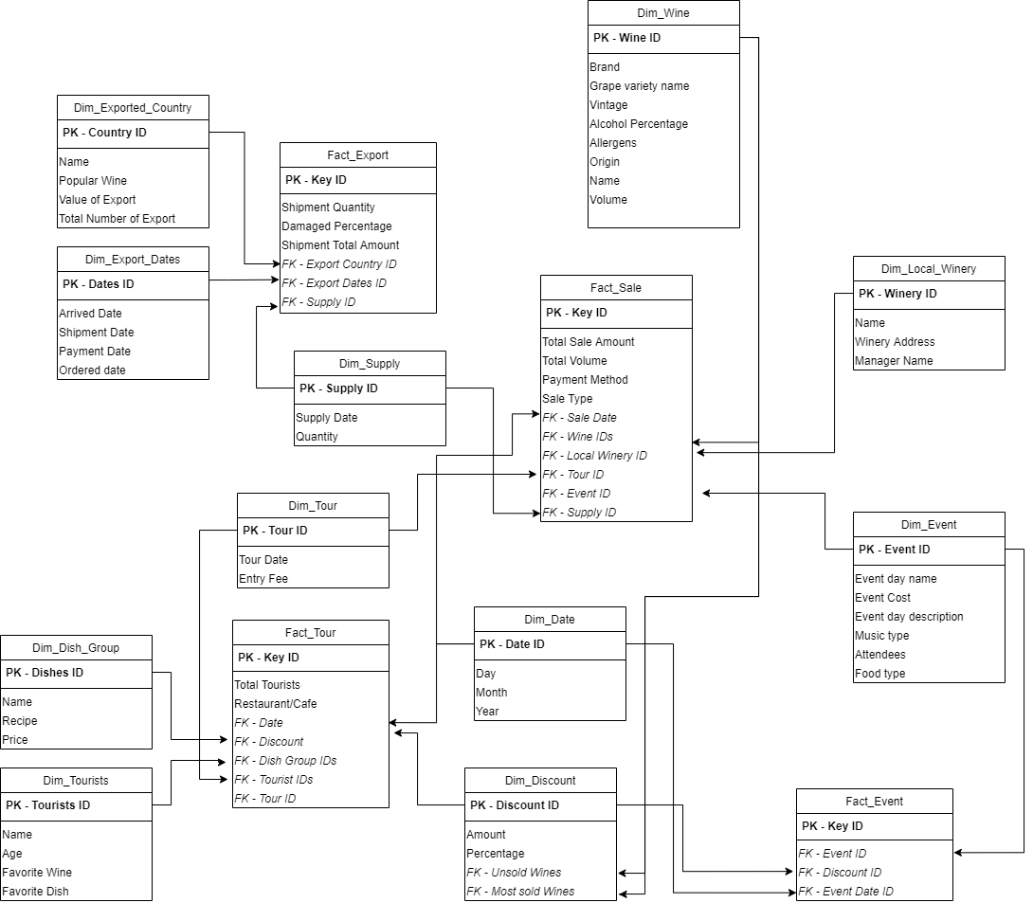

1. Create the following table with a row for each fact table in your design, indicating the granularity of each fact and a brief justification for choosing that granularity. (12 marks).

|  |  |  |  |
| --- | --- | --- | --- |
| **Fact table name** | **Fact granularity** | **Fact table type** | **Brief justification** |
| Fact Sales | Key ID | INT | Identifier of all sales information |
|  | Total sale amount | DOUBLE | Total dollar amount of particular sale |
| Total quantity | DOUBLE | Total dollar quantity in volume/cartons/bottles of particular sale |
| Sale type | String | Sale type can be online/cellar door/ export |
| Payment method | String | Payment methods can be credit card/cash |
| Sale date | String | Sale occurred on which date |
| Wine IDs | INT ARRAY | Details of sold wines |
| Local Winery ID | INT | Details of the winery where items were sold from |
| Supply ID | INT | Details of the supplies of the items (If Any) |
| Tour ID | INT | Details of tour where sale is done (If any) |
| Event ID |  | Details of event where sale is done (If any) |
| Fact Export | Key ID | INT | Identifier of all export information |
|  | Shipment Quantity | DOUBLE | Total quantity in bottles/cartons/volumes |
| Damaged percentage | INT | damaged wines against the shipped wines percentage in this shipment |
| Total Shipment Amount | DOUBLE | Dollar amount |
| Export Country ID | INT | Details of the export country |
| Export Dates ID | INT | All related dates including shipment date, order date, payment date, arrived date |
| Supply ID | INT | Details of the supplies of the items |
| Fact tour | Key ID | INT | Identifier of all tour information |
|  | Total tourists | INT | Number of total tourists attended |
| Restaurant/Café name | String | Restaurant/Café name |
| Date ID | INT | Date of the tour |
| Dish IDs | INT ARRAY | Dishes picked by tourists |
| Tourist IDs | INT ARRAY | Details of the tourists attended |
| Discount ID | DOUBLE | Discount percentage |
| Tour ID | INT | Details of all tour information |
| Fact Event | Key ID | INT | Identifier of all event information |
|  | Event ID | INT | Details of the event attended |
| Discount ID | DOUBLE | Discount percentage |
| Discount ID | DOUBLE | Discount percentage |

1. Create the following table with a row for each dimension table in your design, giving a brief justification for choosing that dimension, and indicating any attribute hierarchies that exist within the dimension. (12 marks).

|  |  |  |
| --- | --- | --- |
| **Dimension table name** | **Brief justification** | **Attribute hierarchies** |
| Dim Wine | Wine dimension stores all information for a wine | Wine ID, Brand, Grape variety name, vintage, alcohol percentage, allergens, origin, name, volume |
| Dim Local Winery | Local Winery dimension stores all information of a local winery | Name, Manager name, Winery Address |
| Dim Supply | Supply dimension stores information for a single supply process | Supply date, Quantity |
| Dim Exported Country | Exported country dimension stores details of an exported country | Name, Popular Wine, Value of export, Total number of export |
| Dim Export Dates | Export dates dimension stores important dates for an export process | Arrived date, Order date, Shipment date, Payment date |
| Dim Dish Group | Dishes dimension | Name, Recipe, Price |
| Dim Event | Event dimension | Event ID, Event day name, Event Cost, Event day description, Music Type, Food Type, Attendees |
| Dim Tourists | Tourists dimension | Name, Age, Favorite Wine, Favorite Dish |
| Dim Discount | Discount dimension | Amount, Percentage, Unsold Wines, Most sold wines |
| Dim Date | Date dimension | Date ID, Day, Month, Year |

1. Create the following table with a row for each design feature you have used, such as handling of possible null foreign keys, and the inclusion of any fact-less fact tables, degenerate dimensions, and role playing dimensions, junk dimensions, outriggers, mini-dimensions, bridge dimensions or any other design techniques discussed in the lectures. Provide a brief description of each design feature used (how and where it is used – not the theory behind the concept), any possible problems & solutions with a justification for their use (16 marks).

|  |  |  |
| --- | --- | --- |
| **Design feature** | **Brief description** | **Brief justification** |
| Dim_supply and Fact_Sale | Role-playing dimensions | The supply dimension will be referred to fact sale many times |
| Dim_wine and Fact_Sale | Role-playing dimensions | The wine dimension will be referred to fact sale many times |
| Dim_local_winery and Fact_Sale | Role-playing dimensions | The local winery dimension will be referred to fact sale many times |
| Dim_tour and Fact_Sale | Role-playing dimensions | The tour dimension will be referred to fact sale many times |
| Dim_event and Fact_Sale | Role-playing dimensions | The event dimension will be referred to fact sale many times |
| Dim_date and Fact_Sale | Role-playing dimensions | The date dimension will be referred to fact sale many times |
| Dim_supply and Fact_Export | Role-playing dimensions | The supply dimension will be referred to fact export many times |
| Dim_exported_country and Fact_Export | Role-playing dimensions | The exported country dimension will be referred to fact export many times |
| Dim_exported_dates and Fact_Export | Role-playing dimensions | The exported dates dimension will be referred to fact export many times |
| Dim_discount and Dim_Wine | Outriggers | The discount dimension can contain references to wine dimension table |
| Dim_tour and Fact_Tour | Role-playing dimensions | The tour dimension will be referred to fact tour many times |
| Dim_date and Fact_Tour | Role-playing dimensions | The date dimension will be referred to fact tour many times |
| Dim_dish_group and Fact_Tour | Role-playing dimensions | The dish group dimension will be referred to fact tour many times |
| Dim_discount and Fact_Tour | Role-playing dimensions | The discount dimension will be referred to fact tour many times |
| Dim_tourists and Fact_Tour | Role-playing dimensions | The tourists dimension will be referred to fact tour many times |
| Dim_date and Fact_Event | Role-playing dimensions | The date dimension will be referred to fact event many times |
| Dim_event and Fact_Event | Role-playing dimensions | The event dimension will be referred to fact event many times |
| Dim_discount and Fact_Event | Role-playing dimensions | The discount dimension will be referred to fact event many times |

1. Identify which fields from your facts/dimensions are required to answer 7 business questions listed as the Bold words and marked with (*) above. (10 marks)
   1. The trends of the market such as the average value of the exports to each country/area?

Answer: For this, we need to select the Dim_Exported_Country dimension and Fact_Export fact table, so that we can calculate the average value of export for each country by the total number of export and each value of export.

* 1. The arrived date between the ordered date and the payment date between the shipment date, how soon the payment can be received after the shipment?

Answer: We need to select the Dim_Export_Date dimenstion and Fact_Export table to find all the necessary dates for a particular export process.

* 1. Compare the total sales of the Shiraz wine style in last quarter of 2018 with the same period of quarter in 2019.

Answer: We need to select the Dim_Wine dimension and Fact_Sales table to calculate total sale of particular wine style/brand by their sale date in order to compare total sales of last quarter of 2018 and same period of quarter in 2019.

* 1. What wines are not sold during the event discount?

Answer: For this, we need to select Dim_discount dimension and Fact_Event fact table, to see what wines are not sold during a particular event.

* 1. Find out the most popular group of dishes are ordered by the visitors.

Answer: We need to select Dim_Tourists dimension and Fact_Tour fact table to identify the popular dish group among the tourists.

* 1. Find the most popular wine glasses ordered by the visitor.

Answer: We need to select Dim_Tourists dimension and Fact_Tour fact table to identify the popular wine among the tourists.

* 1. Has the holiday period in Christmas month increased the tourist number comparing with the same period in last year?

Answer: We need to Dim_Date and Fact_Tour table in order to find the total number of tourists during Christmas month between one year.